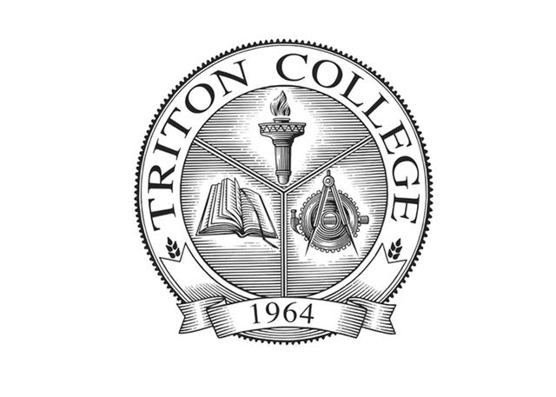

***Bi-Annual Advisory Meeting Agenda***

***Thursday October 14, 2021***

***10:00 am virtual meeting***

**10:00AM** - Welcome

**10:15AM**

* Review Elective Courses
* Review courses for the short certificate dual credit program
* Triton College Foundation auction gift request
* Industry updates and trends

**11:30AM** – Adjournment

Meeting link information is listed in the next page.

Meeting link information

Business and Technology is inviting you to a scheduled Zoom meeting.

Topic: HIA Advisory

Time: Oct 14, 2021 10:00 AM Central Time (US and Canada)

Join Zoom Meeting

https://zoom.us/j/96486068838?pwd=bm9Eb1lZbWMrUVF4TXA0M1d3Slh4QT09

Meeting ID: 964 8606 8838

Passcode: 155467

One tap mobile

+13126266799,,96486068838#,,,,*155467# US (Chicago)

+13017158592,,96486068838#,,,,*155467# US (Washington DC)

Dial by your location

+1 312 626 6799 US (Chicago)

+1 301 715 8592 US (Washington DC)

+1 929 205 6099 US (New York)

+1 253 215 8782 US (Tacoma)

+1 346 248 7799 US (Houston)

+1 669 900 6833 US (San Jose)

Meeting ID: 964 8606 8838

Passcode: 155467

Find your local number: https://zoom.us/u/abte8eV03D