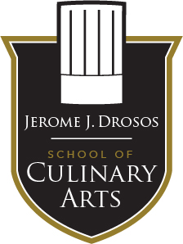
HIGH SCHOOL MYSTERY BASKET CHALLENGE AT TRITON COLLEGE
Date: April 26th 2019
Time: 9am-12pm
Location: B-200

Each High School team is required to plate up 1 entrée for each of the five judges by 10:45 am. The mystery basket will have three ingredients that will all need to be utilized in at least one way in the dish.
9am- Mystery basket ingredients are revealed
9:05-Planning
9:20-Cooking begins
10:45- Plates are due/ no more cooking.
11:15- Judges will announce a winner.

Mystery Basket Ingredients:

- Protein (secret) butchery component
- Vegetable (secret)
- Herb(secret)
- Spice (secret)

Students will have access to our dry storage and walk-in cooler for any ingredients he/she would like to use. If you would like to make sure we have a certain ingredient please email manueluribeespin@triton.edu to ensure we have product by 4/18/19.

