**Outlet and Switched Lamp Project**

1. Grab an octagon box and a 1900 box and remove 1 ½” knockout on each in the desired location to connect them with a piece of conduit pipe (do not remove the ¾” knockouts on the 1900 box)
2. Cut a piece of conduit to your desired length (example shows a piece of 5-1/2” conduit) or bend a piece on conduit as you like. Remember to do a good job reaming the sharp edges
3. Grab 2 box connector fittings and tighten them to each box. Then conduit the conduit to each connector
4. Feed a hot and neutral through the pipe leaving 4 or 5 extra inches sticking out of each box
5. Grab a white plastic light bulb socket and wire the hot and neutral in the octagon box
6. **Have me check the connection** before you carefully screw the plastic socket to the octagon box
7. Grab an extension cord and cut off the female end or cut the cord even shorter to your desired length
8. Carefully cut off about 4 or 5 inches of the orange extension cord insulation to expose the wires
9. Grab a Romex connector, remove another knockout on the 1900 box, and connect it to that hole
10. Feed the stripped extension cord through the Romex connector and clamp the connector securely to the end of the orange insulation
11. Grab a 2 way switch and a duplex outlet and break off the 4 corner tabs on each. Do this with a pair of pliers by bending the tabs back and forth until they snap off
12. Pigtail the ground wire to the cord, outlet, and switch
13. Connect the neutrals from the cord and light to the outlet
14. Connect the hot from the light to one of the hot screws on the switch
15. Connect the hot from the cord to one of the hot screws on the outlet
16. Grab a small piece of black wire and connect to the other hot screw on the outlet and the other hot screw on the switch
17. **Have me check the connections before you move to the next step**
18. Wrap electrical tape around the outlet and the switch to cover the screw terminals
19. Grab metal cover plate for switch and outlet
20. Remove screws on switch and outlet
21. Open metal cover plate and use screws and nuts to secure outlet and switch to the plate (use pliers to hold the nut on back of the plate and a screwdriver to tighten from the front of the plate)
22. 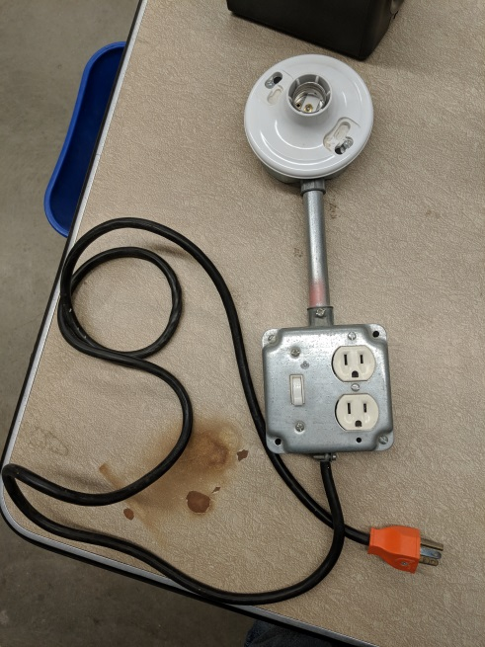Remove 2 screws from 1900 box and install cover plate to box with them
23. Grab a light bulb and an outlet tester and bring to me so we can test it together. **PLEASE DO NOT TEST ON YOUR OWN**