**Industrial and Manufacturing Communication Process**

Purpose:

Communicating a method to create a product or perform a process in any industry is key to effectively creating the end product. The communication allows companies, supervisors, and workers to efficiently produce thereby saving the company money for increased profit and reducing the cost to the consumer creating a larger market based on affordability.

One example of this is the creation of a plan of procedure that can be followed in the woodshop while building a project. While you are learning, the concerns over speed are less important than learning how to safely use the equipment in the classroom and then create a product. While following the procedure provided in this project, consider whether there are steps that you needed to add to the plan or if there were any steps that you needed to perform that were not explicitly provided. If so, how did you think about the process and what would you do differently when designing a project of your own?

***Terms used in industry that could apply to this project in mass production***.

|  |  |
| --- | --- |
| **Term** | **Definition** |
| Bill of Materials | A formalized list of parts or materials needed to produce a product which typically breaks down various descriptions such as name, size, quantity, material, unit cost, etc. |
| Plan | A drawing or design of a product that can be used to visualize what is to be created. |
| Procedure | A list of steps created to describe a process in detail for someone to follow during the process of creating a product. |

**Desktop Box Procedure**

**Bill of Materials**

|  |  |  |  |
| --- | --- | --- | --- |
| **Quantity** | **Part Name** | **Dimensions (T x W x L)** | **Notes** |
| **2** | **Top and Bottom** | **½”x 5” x 7”** | **-** |
| **2** | **Front and Back** | **½” x 3” x 7”** | **-** |
| **2** | **Sides** | **½” x 3” x 4-½”\*\*** | **\*\*Do not cut to final length, CUT TO FIT!** |

**PLAN**

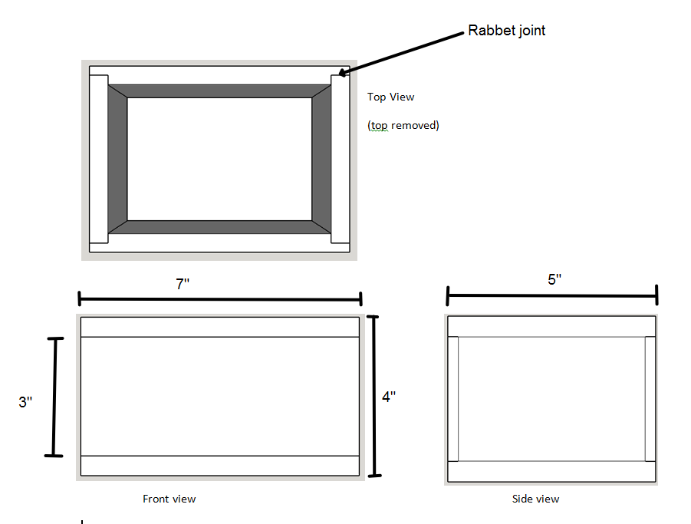

**Procedure**

**Layout Parts**

**Material:** Board you got from your instructor, pencil, tape measure, square

1. Mill your board flat and square, plane it to final thickness, then **STOP MILLING!**

2. Draw rough lines to show where each part will come from on your board

(NOTE: Your lines do not need to be absolutely accurate, they are just there to confirm that you have enough board for all the parts and that you are planning the order of your rip and crosscuts)

2. Number the cuts in the order in which you will make them and label them

(EXAMPLE: 3” rip cut)

3. **GET APPROVAL FROM INSTRUCTOR BEFORE PROCEEDING!**

***Cutting Parts to Final Width and Length (Except Sides)***

1. Use the rip table saw to cut boards to final width. Be sure to follow the established order of your cuts.

2. Use the crosscut table saw to cut your parts (**except for the sides!**) to their final length

3. Remember: **If you want parts to be the same size, they need to get cut at the same setting on the same day.**

***Cutting Rabbets in the Front and Back***

**Materials:** miter gauge with fence attached to it, sacrificial rip fence

1. Use the dado table saw. Be sure the blade is set to the proper height of ¼” **before** setting the fence.

2. Set the fence to cut a ½” wide rabbet in the ends of the Front and Back pieces (4 rabbets total). *Use your side pieces to help you set that distance.*

3. Use the miter gauge to help you move the pieces in a straight line. *Be sure the miter gauge is square to the rip fence.*

4. Cut all 4 rabbets. Confirm that your side pieces will fit completely into each rabbet.

***Cutting Sides to Final Length***

**Materials:** Box parts, pencil, square, crosscut table saw

1. Lay your Front and Back on the Bottom exactly as they will be when the box is glued together. Keep the outside face of the Front and Back flush (even) with the outside edges of the bottom.

2. Make a light mark on the inside face of the rabbet where it meets the face of the bottom for your Front. Repeat the same step for the Back. You now have marked the exact length that the Sides need to be!

3. Transfer that length onto one of your Sides (this is called a Direct Measurement). Carefully mark that line square across the edge of one of your sides.

4. Use that mark to line up your stop on the crosscut table saw and lock the stop in place. **Note: It is better to have your sides slightly TOO SHORT rather than too long at this point**

5. Cut both Sides to length at the same stop setting.

***Gluing (Assembly)***

**Material:** Box parts, glue, bench vise, 2 blue quick clamps

1. Glue parts in this order: **Front, Side, Side, Back, Top**

**NOTE: All gluing should take place on the Assembly Table, NOT ON WORKBENCHES!!**

2. Apply glue to the bottom edge of the Front and place it on the Bottom

3. Apply glue to the bottom edge AND the ends of a Side and place it on the Bottom. Repeat this for the other Side.

4. Apply glue to the bottom edge of the Back and place it on the bottom.

5. Apply glue to the top edge of the Front, Back and Sides all at once.

6. Place the Top. At this point, make sure all pieces are lined up exactly where you want them. You will not have a lot of time to make adjustments. Be sure the sides are sitting all the way down in their rabbets and that the faces of the Front and Back are not sticking out past the edges of the Bottom.

7. Press the top in place for 30 seconds or so and let the glue start to set a little bit.

8. Take the entire box and place it in an open vise so that the Front is facing the floor and the Back is facing the ceiling. Slowly tighten the vise, being sure that pieces are not sliding around.

9. Use the 2 blue clamps to squeeze the Front and Back towards each other (the vise should be squeezing the Top and Bottom towards one another).

10. Check your alignment one more time and wipe off any excess glue before it dries.

***Belt Sanding the Box***

1. Use the belt sander to LIGHTLY sand all the faces and edges of the box.

2. Make sure that the box sits flat on the table of the belt sander and that you keep the box moving to avoid burning or creating non-square corners

3. Be sure to belt sand in the SAME DIRECTION as the grain in order to save yourself a lot of sanding later.

***Decorative Edge***

1. Use the router table to cut a decorative profile on the edges and ends of the Top.

2. Cut the ENDS FIRST (across the grain).

3. Place the box against the router table fence and, with a secure grip, move the box at a consistent speed along the bearing of the bit.

4. Once the ends are cut, cut the two long grain edges (with the grain).

***Coarse Sanding***

**Material:** 100 grit sand paper, sanding block (made from scrap by you)

1. Sand off all pencil marks, scratches and burn marks from all faces of the box

BE SURE NOT TO SAND THE DECORATIVE EDGE OR ELSE YOU WILL CHANGE ITS SHAPE!

2. You do not need to sand with the medium (120-150) or fine (220) sandpaper yet, although you can.

***Cut the top off***

**Material:** Rip table saw, small handsaw, bench vise

1. Set the height of the table saw so that it is just below the thickness of the Bottom of the box. This is a Direct Measurement made by placing the box directly next to the blade and placing the highest tooth of the blade slightly lower than the glue joint of between the bottom and the Front/Back/Sides (the thickness of the bottom should be the same as the rest of the box).

2. Set the distance between the fence and the blade. There is no correct measurement for this, just line up where you want the lid to start and lock the fence.

3. **WITH YOUR INSTRUCTOR’S SUPERVISION, cut all four sides of the box. You should not go all the way through (unless you belt sanded way too much earlier).**

4. Place the box in a bench vise and use the small handsaw to cut the rest of the way through the walls of the box to create a lid.

5. The lid may need some additional sanding to clean up waste material.

***Creating a lip for the lid***

**Material:** Scrap wood (can be multiple pieces)that can be planed down to ¼” thick or less (must be wide enough that it can fit inside the box and stick up past the top edge by at least ⅛”), glue, small spring clamps

1. Locate necessary scrap wood and rip it to a final width

2. Plane it to final thickness.

3. Take a Direct measurement for the length of the first piece using your box as a guide. The piece should fit VERY TIGHTLY into the box. A good way to do this is to make sure you cut your piece just a little bit long and belt sand it down to a perfect fit.

4. Repeat for the other 3 pieces. Keep in mind that 2 of the pieces will overlap the other two.

5. Use a VERY SMALL AMOUNT OF GLUE on one face of each piece and glue it into the inside of the box.

6. Use the spring clamps to hold the pieces in place while the glue dries. If you sized the pieces well, you may not need clamps at all, but have them ready just in case.

7. Tune up the fit of the lid and then see your instructor for tips on how to do that.

***Final Sanding and Finishing***

1. Complete all surface preparation steps like normal.

2. Apply finish to the outside of the box only. Don’t put finish on the inside edges of the box or lid yet.

3. Let the finish dry until the next class, sand lightly with worn 220 grit paper, wipe off dust and repeat.

4. Repeat these steps until you achieve your final finish.

5. At that point, you can apply finish to the inside edges only (nothing on the outside) and let it dry. You may use only one coat if you would like, or you can use multiple coats.

Congrats, your Box is finished! Get it graded and take it home!!

**Conclusion Questions for Reflection**

1. How would you communicate this process verbally to a peer if you were to explain how you made your box? (Practice with a classmate and then paraphrase your description)
2. What part of the plan was most helpful when creating your project?
3. What part of the process was the most confusing or difficult to follow?