Math-in-CTE Lesson Plan
Lesson Title: Three Milliseconds to Google | Lesson #

Occupational Area: Information Technology
CTE Concept(s): Networking
Math Concepts: Conversions, Distance Formula

Lesson Objective: | Student will demonstrate a general understanding of:  - Logistics of pulling up a web page  - How the fastest route is optimized  - How quickly the Internet functions
Supplies Needed: | - Computer  - Either Paper Map of US/Digitized Map of the US
Link to Accompanying Materials: | IP Location - https://www.iplocation.net/  Command Line – Start > cmd  Scribble Maps - http://www.scribblemaps.com/  Video - How Does the Internet Work?  https://www.youtube.com/watch?v=ZonvMhT5c_Q

The "7 Elements" | Teacher Notes  ( Answer keys)
- Introduce the CTE lesson.  Ask students “What’s happening in the background when you pull up a website?”  What are packets of data? | Show Video  https://www.youtube.com/watch?v=ZonvMhT5c_Q  Discuss how packets travel through the Internet. They split apart and come back together at their final destination – and take various routes to get there the quickest.  Blink your eye. That took five milliseconds. (frame of reference).
2. Assess students’ math awareness as it relates to the CTE lesson.  Teacher’s will ask the students the following questions about math:  * Blink your eye (millisecond reference)  * Do you understand latitude and longitude? (coordinates)  * What is the distance formula?  * “Traveling Salesman” Problem | Sample Dialog for Teacher  As prep, teacher will ask student to blink their eye, which takes 5 milliseconds. This will provide a frame of reference for that computation.  Terminology:  Millisecond: one thousandth of a second.  Latitude: the angular distance of a place north or south of the earth's equator, or of a celestial object north or south of the celestial equator, usually expressed in degrees and minutes.  Longitude: the angular distance of a place east or west of the meridian at Greenwich, England, or west of the standard meridian of a celestial object, usually expressed in degrees and minutes.  Distance Formula: a variant of the Pythagorean Theorem that you used back in geometry. Here's how we get from the one to the other: Suppose you're given the two points (–2, 1) and (1, 5), and they want you to find out how far apart they are.  “Traveling Salesman”: a mathematical problem in which one tries to find the shortest route that passes through each of a set of points once and only once.
3. Work through the math example embedded in the CTE lesson.  Show student how to do a Distance Formula problem. | We will discuss the “Traveling Salesman” problem.  What is the distance formula?  What is the complication of using the distance formula for latitude and longitude? The Earth is curved so the distance is not a direct line.  How, then, do we find the distance between two points on something curved, such as Earth? Use a haversine formula  For our purposes, we will use an app that completes these calculations but we will need to convert kilometers to miles:  http://www.movable-type.co.uk/scripts/latlong.html
4. Work through related, contextual math-in-CTE examples.  Have students complete a walk-through of CMD software and understanding of TRACERT (hops, packets, etc.)  What is tracert?  https://kb.intermedia.net/article/682 | Teacher  Students will run through the TRACERT four times and compute an average time of travel.  Use website to the left in order to complete the task.  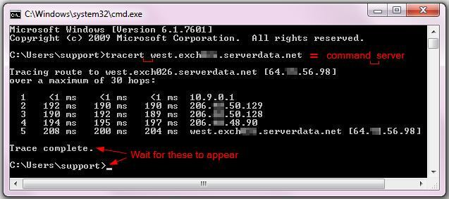
5. Work through traditional math examples.  Provide visual example of different distance formula questions. | NOTE:  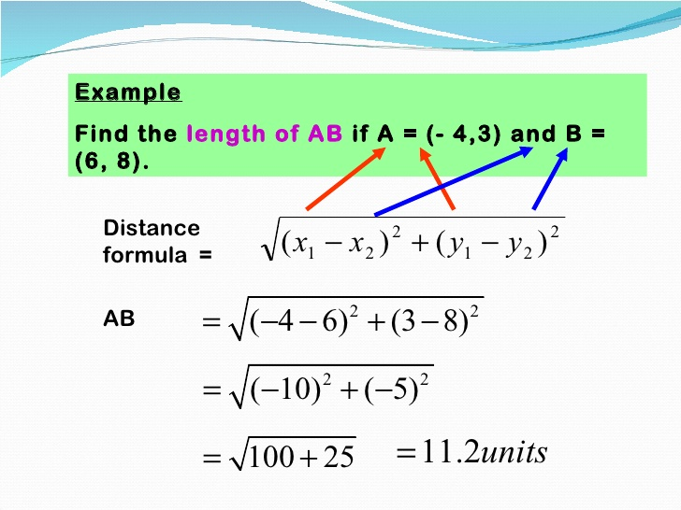  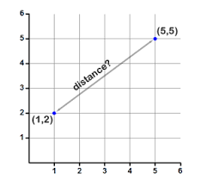  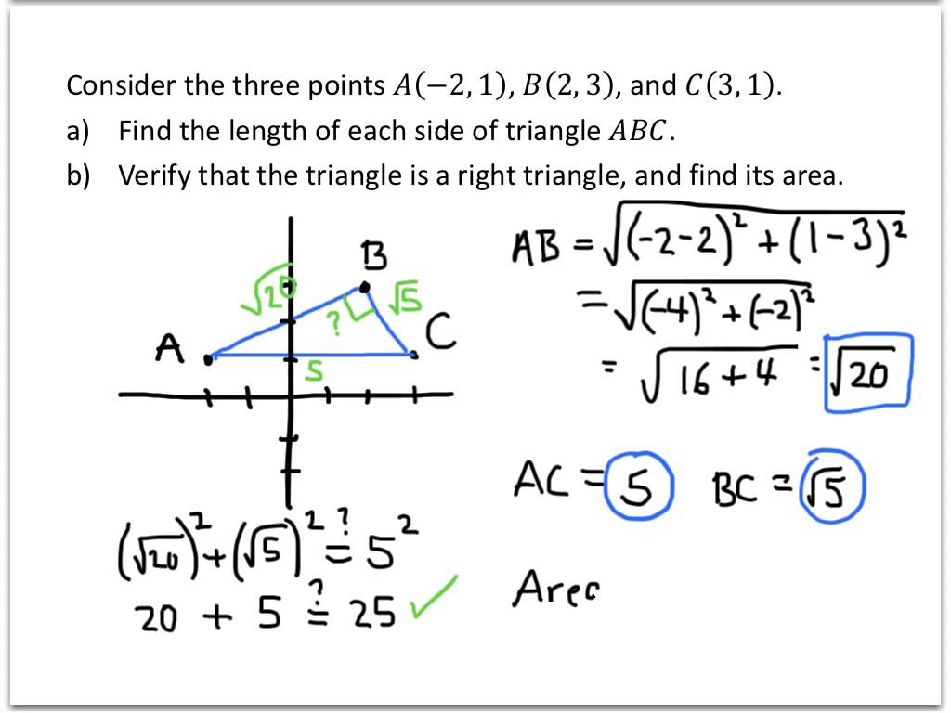
6. Students demonstrate their understanding.  Have students run a TRACERT to a specific destination. | This will bring all the information together. The TRACERT will show how packets travel through the web and students will average the time of travel.
7. Formal assessment.  Students will average the route and draw the route on a Scribble Map. | Teacher Note:  Students will also draw coordinates on the map to show how the packets travel via longitude and latitude. They will also calculate the physical distance on how far the packet travels.

Further Resources

IP Location - https://www.iplocation.net/

Command Line – Start > cmd

Scribble Maps - http://www.scribblemaps.com/

Video - How Does the Internet Work?
https://www.youtube.com/watch?v=ZonvMhT5c_Q

What is tracert?
https://kb.intermedia.net/article/682

http://www.movable-type.co.uk/scripts/latlong.html

