Unit 7 Name________________________
Exit Questions Date_________________________
Test for congruence Period________________________
Answer with SSS, SAS, ASA, and AAS or not congruent
1.  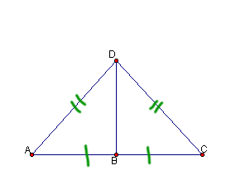  The triangles are congruent  by _______ | 2.  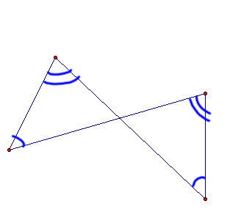  The triangles are congruent  by _______ | 3.  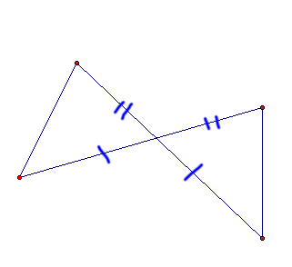  The triangles are congruent  by _______
4.  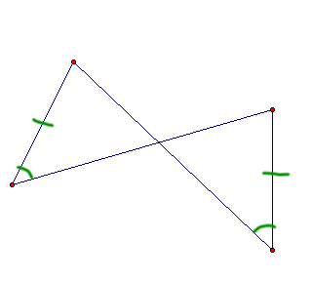  The triangles are congruent  by _______ | 5.  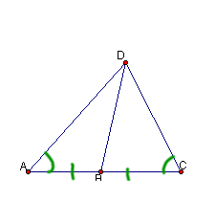  The triangles are congruent  by _______ | 6.  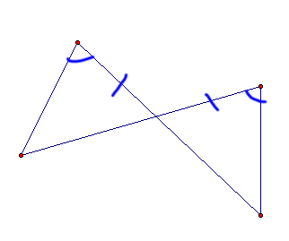  The triangles are congruent  by ________

