Unit 7 review Name_______________________________
Date___________________Period ______

1. Δ EFG ≅ Δ JKL. List the six pairs of corresponding congruent parts. Remember to use the proper notation.

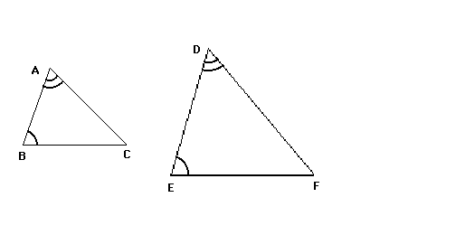

2. Which method, if any, can be used to prove the triangles are congruent?

a. SAS | b. SSS | c. AAS | d. ASA | e. HL | f. Not Congruent

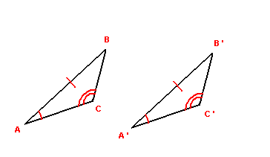
3. Which method, if any, can be used to prove the triangles are congruent?

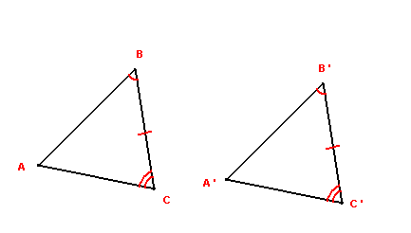
a. SAS | b. SSS | c. AAS | d. ASA | e. HL | f. Not Congruent

4. Which method, if any, can be used to prove the triangles are congruent?

a. SAS | b. SSS | c. AAS | d. ASA | e. HL | f. Not Congruent

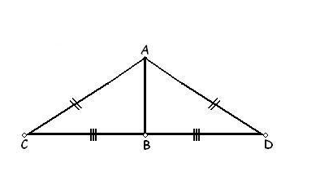
5. Which method, if any, can be used to prove the triangles are congruent?

a. SAS | b. SSS | c. AAS | d. ASA | e. HL | f. Not Congruent

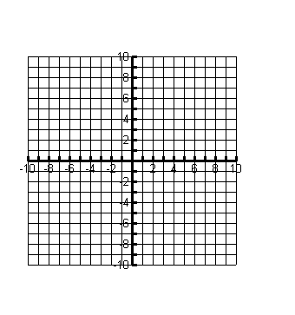
6. Use the following coordinates to prove whether or not is congruent to. Remember to show all work and use necessary postulates or theorems to justify your answer for full credit.

A(-1, 2) B(2, 4), C(3, 0) D(0, -3)

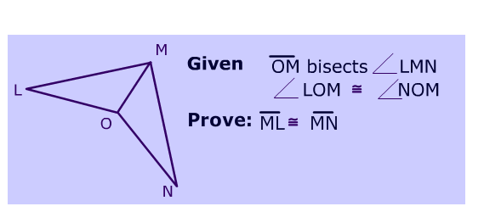
8.

Statements Reasons___________

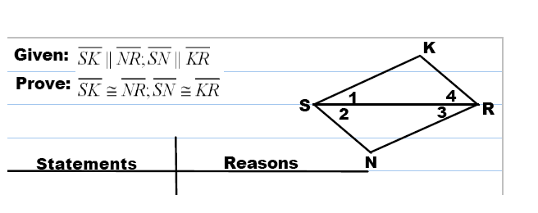

9.

