Name_______________________________
Date________________________________
Naming Congruent Triangles Period______________________________

- Warm up

Classify the triangles by both the sides and angles

Sides______________________  Angles______________________ | 2.  Sides______________________  Angles______________________
3. Solve for x

Congruent triangles have the same size and the same shape. Since all the corresponding sides and angles are congruent, the triangles will fit exactly on top of one another. If a mira can be placed so that the image of one triangle fits on top of another, the two triangles must be congruent.

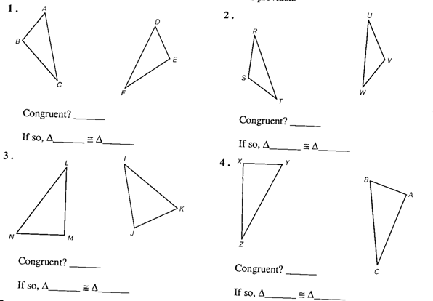

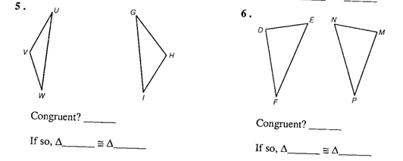

- Notes

- What are congruent triangles?

  - How do the measures of pairs of corresponding angles compare in size?

  - How do the measures of pairs of corresponding sides compare in size?

- If ΔPQR ≅ ΔMNO, what pairs of angles correspond to each other?

- If ΔPQR ≅ ΔMNO, what pairs of sides correspond to each other?

- If ΔABC ≅ ΔGHI, is that the same as ΔABC ≅ ΔHIG? Explain

- If ΔABC ≅ ΔGHI, is that the same as ΔBCA ≅ ΔHIG? Explain.

- If ΔTUV ≅ ΔDEF, then ΔVTU ≅ ____________.

- Why are slides, flips, and turns called “congruence transformations?”

- Examples

A. Identify the congruent triangles in each figure
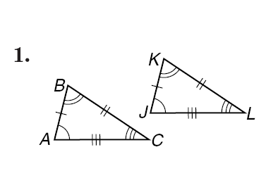 |  | 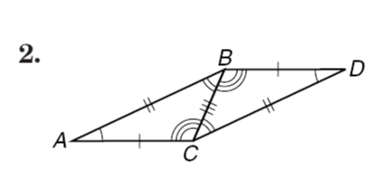
B. Describe the congruence transformation between the two triangles as a slide, a flip, or a turn. Then name the congruent triangles.
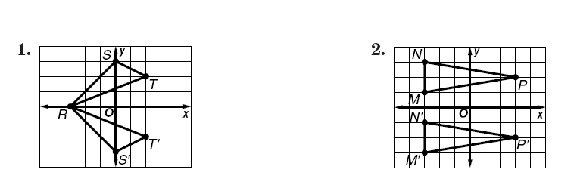
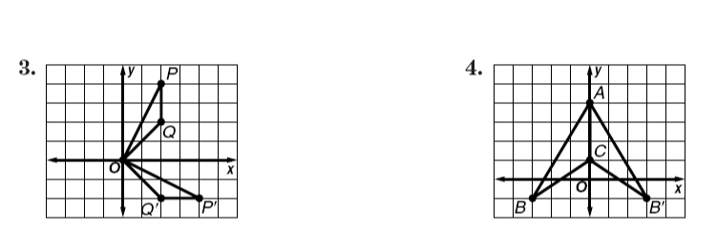

- In class practice

Identify the congruent triangles in each figure
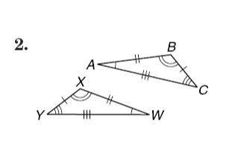 |  | 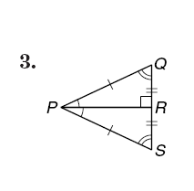
Name the congruent angles and sides for each pair of congruent triangles.

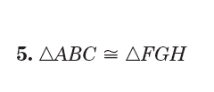 | Congruent angles: Congruent sides:

