Unit 7 Name_________________________
Student Notes Date__________________________
Proving Congruent triangles Period________________________

I. Warm up

1. Name the 4 ways to prove triangles are congruent

II. In Class Practice
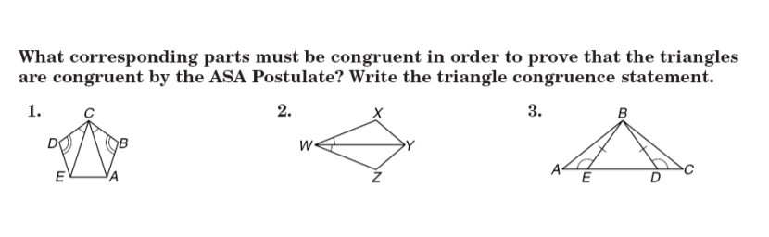
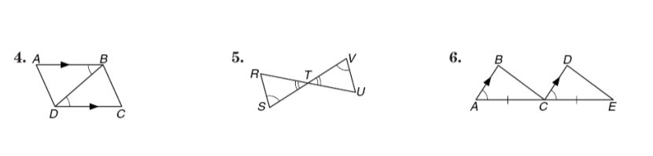
In Exercises 1 and 2, draw and label ΔABC and ΔDEF. Indicate which additional pair of corresponding parts needs to be congruent for the triangles to be congruent by the AAS Theorem.

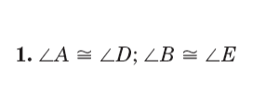 | 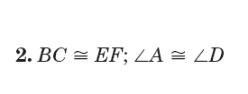
(Make your drawing for #1 here) | (Make your drawing for #2 here)

III. Examples
- Given: ED = CE
m∠D = m∠C

Prove: ΔDEA ≅ Δ CEB

- Given: line AD // line BC
∠A ≅ ∠C

Prove: ΔADB ≅ ΔCBD

- Given : ΔBAC is isosceles
D is the midpoint of segment BC

Prove: ΔABD ≅ ΔACD

- Given: Segment AD bisects ∠BAC
AB = AC

Prove ΔBAD ≅ Δ CAD

- Given: AB = CD
AC = DB

Prove: ΔBAC ≅ ΔCDB

- Given: ∠A ≅ ∠C
BC = AB

Prove: ΔBAE ≅ Δ BCD
- Given: segment AD ⊥ segment BC
AB = AC
m∠B ≅ m∠C

Prove: ΔABD ≅ ΔACD

- Given : m∠BAD ≅ m∠CAD
m∠ADB ≅ m∠ADC

Prove: ΔABD ≅ ΔACD

