Unit 7 Name________________________
Exit Questions Date_________________________
Test for congruence with SSS and SAS Period________________________

By__________________ | 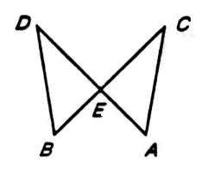 | 2.  By__________________

