Unit 7 Name___________________
congruent triangles Date____________________
Practice Work Period__________________

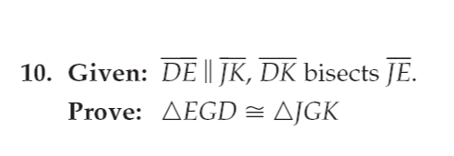 | 