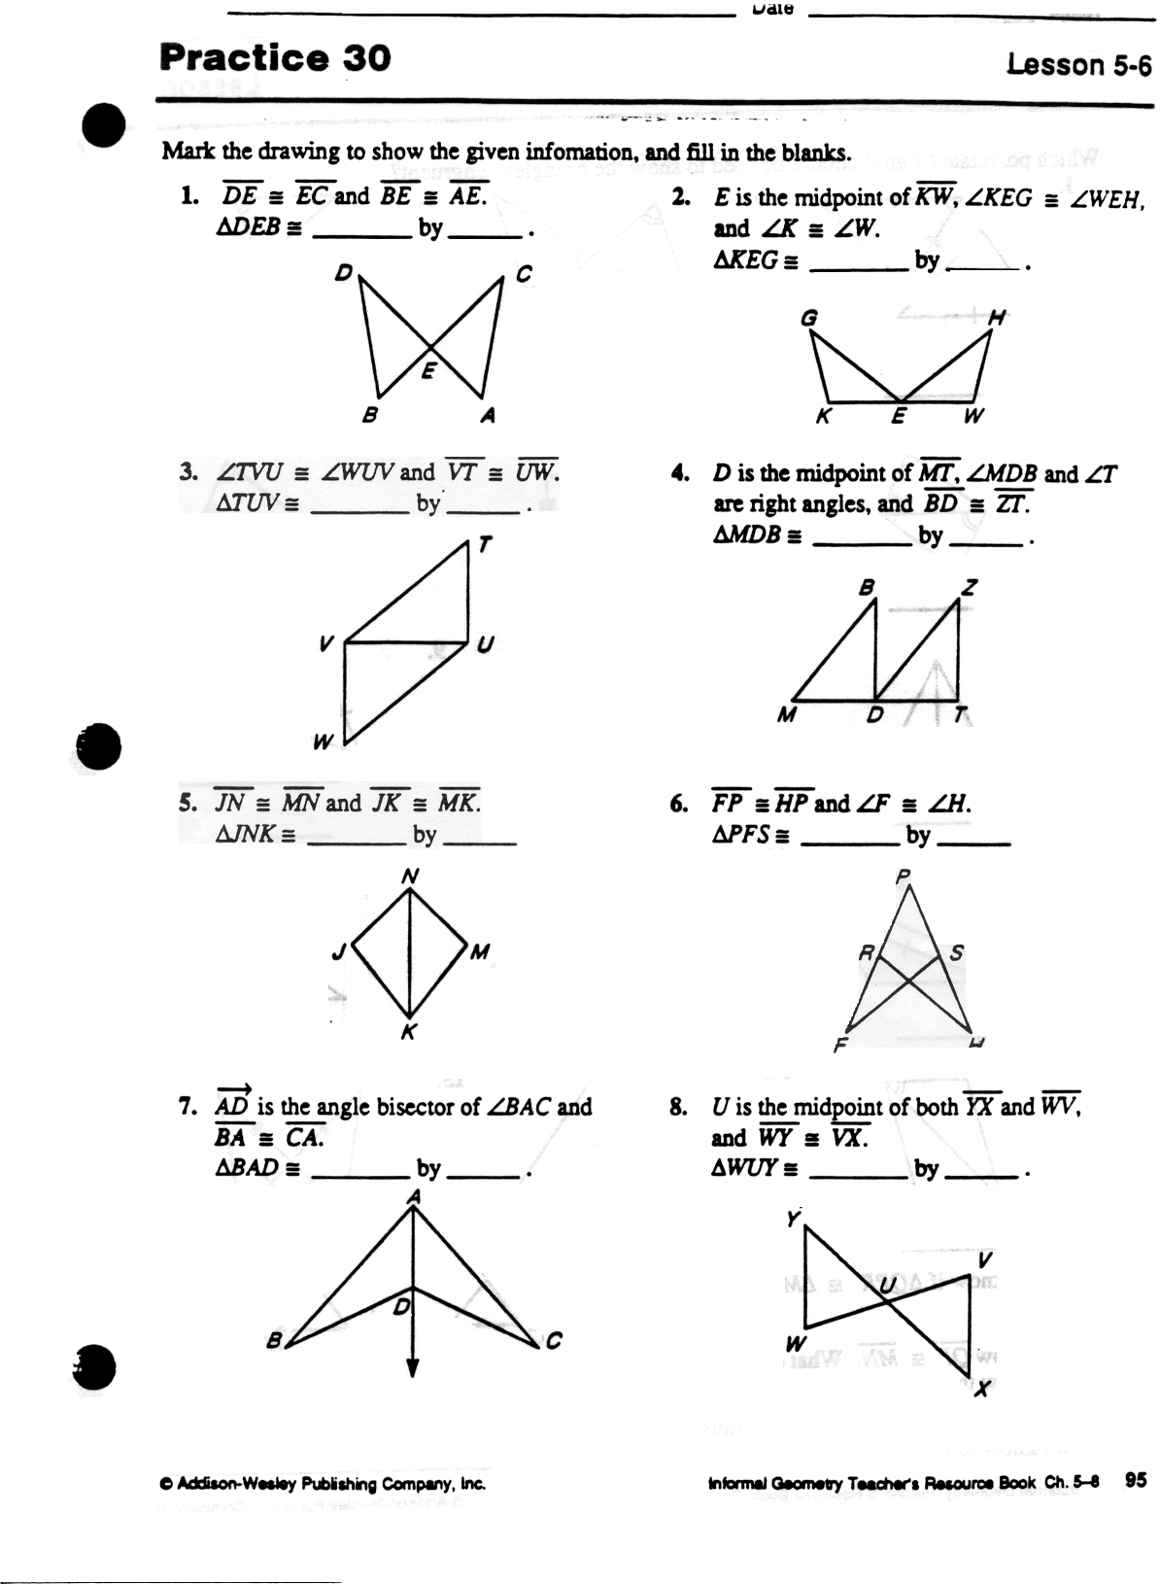
(Answers can be: SSS, SAS, ASA, or AAS)
Unit 7
Practice work
Proving Triangles Congruent
Period______________
Name

