Unit 7 Name___________________
Corresponding Parts of Congruent Triangles are Congruent Date____________________
Practice Work Period__________________

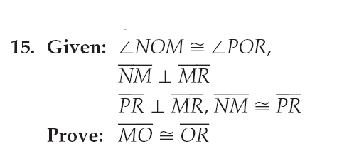 | 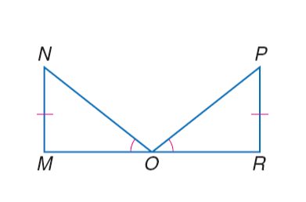
16. Given: X is the midpoint of ,  ∠XLN ≅ ∠XDB  Prove: | 