Geometry In Construction Name __________________________
Unit 6 Test Date ________________ Period ____

- In, m∠WXY = 60°, WZ = 12 in.
Find the value of each of the following:

- m b. m∠WZY

- Circumference d. length of

- has a radius of 78 cm. , and GJ = 60 cm.

a. Find GK. b. Find KH.

- In , with radius of 8.8cm, SU = 16, YW = 16, and

a. Find YZ.

b. Find

c. Draw. Find

d. Find RV.

- Find the value of x. 5. Find x.

6. Line BC is tangent to. The radius is 15 cm. 7. Polygon RPNT is circumscribed about.
Segment BC = 20 cm. Find the value of x. Find the values of x and y and the perimeter
of polygon RPNT
(x + 1)

8. EFGH is a quadrilateral inscribed in circle P with mand m. Draw a diagram and
find the measures of and .

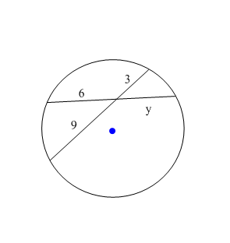
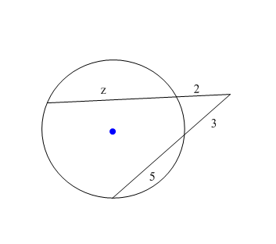
9. Find the value of y. 10. Find the value of z.

11. Write the equation of circle A.

12. What is the center and radius of the circle with equation?

Center: _________________

Radius = __________

13. Graph the parabola Draw and label directrix, focus, and vertex.

