Unit 4: Know Your Quadrilaterals Part 1
Geometry In Construction

Classify each shape as a quadrilateral, parallelogram, rectangle, rhombus, square, trapezoid, isosceles trapezoid, kite or none of these. First, give each shape as many possible names. Then, from that list circle the best name for that shape. (note: not all shapes will have multiple names, but some will.)
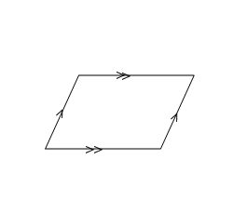
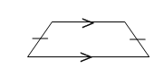  1.) | 2.) | 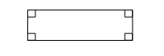  3.)
4.) | 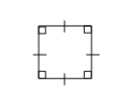  5.) | 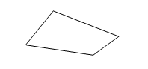  6.)
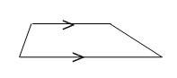  7.) | 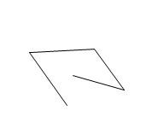  8.) | 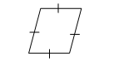  9.)

Unit 4 Know Your Quadrilaterals Part 2
Geometry

Classify each shape as a parallelogram, rectangle, rhombus, square, trapezoid, isosceles trapezoid, or kite. Select only the best name for that shape.
Pay attention to tick marks, each shape is not drawn to scale (obviously, you should not be writing rectangle by each one).

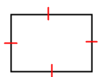  1.) | 2.)  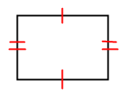 | 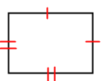  3.) | 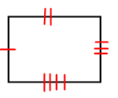  4.)
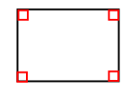  5.) | 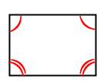  6.) | 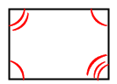  7.) | 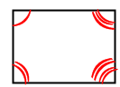  8.)
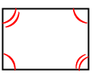  9.) | 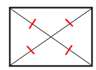  10.) | 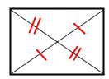  11.) | 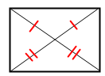  12.)
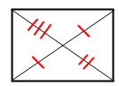  13.) | 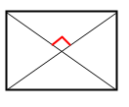  14.) | 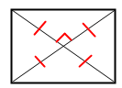  15.)

