Unit 4: Know Your Quadrilaterals Part 3
Geometry

Directions: Complete the following table. Put a check mark (√) in each space if the quadrilateral always has the given property.
Property | Parallelo-  gram | Rectangle | Rhombus | Square | Quad. | Trapezoid | Isosceles  Trapezoid | Kite
1. All angles add to 360º
2. 2 pairs of opposite sides are parallel
3. Only 1 pair of opposite sides are parallel
4. 2 pairs of opposite sides are congruent
5. Only 1 pair of opposite sides are congruent
6. All sides are congruent
7. Two pairs of adjacent sides are congruent
8. Exactly one pair of opposite angles are congruent
9. Consecutive (interior) angles are supplementary
10. Two pairs of opposite angles are congruent
11. All angles are congruent
12. Diagonals bisect each other
13. Only one diagonal is bisected
14. Diagonals are perpendicular
15. Diagonals are congruent
16. Each diagonal is an angle bisector
Know your Labels Part 4
Geometry
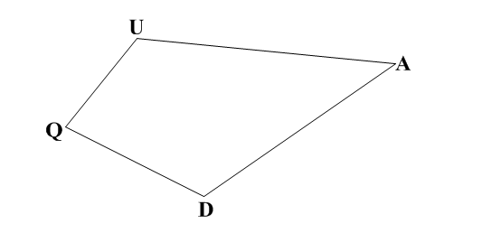
1.) Use Quadrilateral QUAD to answer the following questions.

a.) Name a side that is non-consecutive with AD.

b.) Name the vertices that are consecutive with Q.

c.) Draw in and Name all diagonals.

d.) Name a non-consecutive angle with U.

e.) If QUAD is a Kite, determine which angles are congruent.

f.) If QUAD is a Kite, determine which sides will be congruent.

g.) If QUAD is a Kite, which angles will be bisected by the diagonals?

2.) Use Isosceles Trapezoid TRAP to answer the following questions.

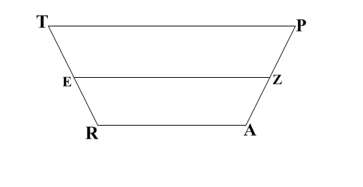
a.) Name the bases.

b.) Name the legs.

c.) Name the median.

d.) Name a set of base angles that are congruent.

e.) Name two sides that are parallel.

f.) Name six pairs of segments that are congruent.

g.) If TP = 38 and EZ = 23, find RA.

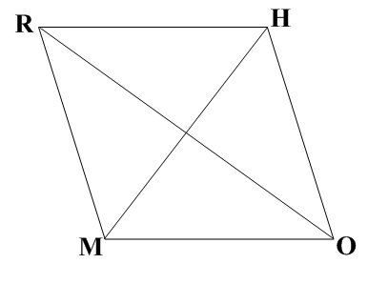
3.) Use Rhombus RHOM to answer the following questions.

a.) Name a set of supplementary angles.

b.) Name a set of perpendicular lines.

c.) Name all sides that are congruent with RH.

d.) True or False: The diagonals are congruent.

e.) If , find all the other angles in the figure.

