Geometry in Constructing Name: ___________________________________
Unit 3 Test Date: ________ Period: ________

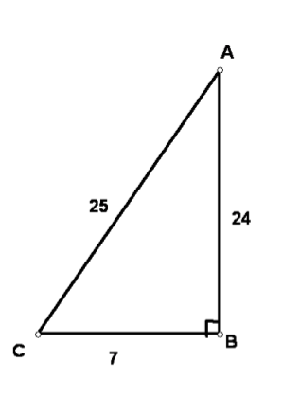
Use triangle ABC to answer the following questions. Leave your answers as reduced fractions.

1. tan <A

2. sin <A

3. cos <A

4. tan <C

5. cos <C

6. sin <C

SHOW ALL WORK FOR 7 – 9 round to the nearest hundredth

7. Find x and y

X = ______

Y = ______

8. Find x and y

x = _______

y = _______

9. Find x and y

X = _______
y

Y = _______

Draw a diagram for each problem. Find the indicated measure to the nearest hundredth.

10. A student is laying in the grass 50 feet away from a tall building. If the angle of elevation of the building is 74 degrees, then how tall is the building?

- A rectangular enclosure is 75m by 100m. How much fencing is needed to divide the enclosure diagonally?

- Two wires support a 9-meter tall utility pole. Each wire attached to the top of the pole and anchored to the ground 3m from the base of the pole. How many meters of wire are needed for the two wires?

13. | The angle of depression from an observation tower to a fire is 28°. The height of the tower is 90 feet. How far is the fire from the base of the tower? | . The fire is _________________________

12 cm  10 cm  8 cm | Extension Problem  Create a spiral by moving forward 12 cm, turning right and going 10 cm, turning right and going 8 cm, and so on, moving 2 cm fewer each time, stopping at 0 cm.  What is the total length of the spiral?  What is the distance from the starting point to the ending point of the path?  What is the angle west of north used to get directly back to the starting point from the ending point?  9. The total length of the spiral is ______ cm. : The distance from the starting point to the ending point of the spiral is ____________ cm.  The angle formed traveling from the ending point back to the starting point is _____ degrees west of north.

