Unit 2 Volume QUIZ Name __________________________

Find the volume of each figure

- The volume of a right triangular pyramid is 200 cm³. The triangular base is a right angle isosceles triangle with a leg length of 8 cm. Find the height of the prism. (Remember to draw a diagram).

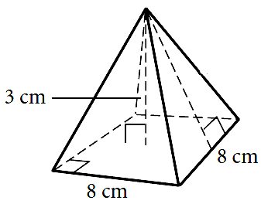

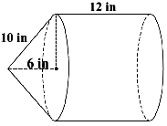

- The volume of a cylinder is found by using the formula V = πr²h. How do the volumes of cylinder A and cylinder B compare?
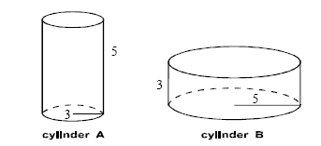
A. The volume of cylinder A is larger.
B. The volume of cylinder B is larger.
C. It is not possible to compare the volumes.
D. The volumes of cylinder A and cylinder B are the same.

- Determine the capacity of the box if the base has a width and length of 18 in and 24 in and a height of 16 in.
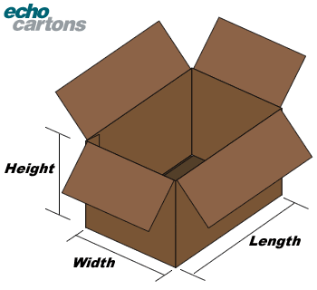

- Yvette has two choices of paint to buy, the new paint that comes in a fancy cone-shaped container for $14.95 and the Home Depot brand come in a cylinder for $21.85. If the containers have the following dimension, which one would you say has the better buy?
4in
13in
8ft
13ft

Extension Problem

- Eight wooden spheres with radii of 3 inches are packed snugly into a square box 12 inches on one side. The remaining space is filled with packing beads. What is the volume occupied by the packing beads? What percentage of the volume of the box is filled with beads?

