Special Right Triangle Quiz Name___________________

1) If , then the exact value of is…  a) b) c) d) | 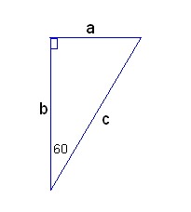
2) If , then the exact value of is…

a) b) c) d)
3) If, then the value of to the nearest tenth is…

a) b) c) d)

4) If, then the value of to the nearest tenth is…  a) b) c) d) | 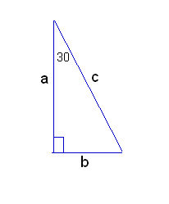
5) If, then the value of to the nearest tenth is…

a) b) c) d)
6) If , then the value of to the nearest tenth is…

a) b) c) d)

7) If, then the value of to the nearest tenth is…  a) b) c) d) | 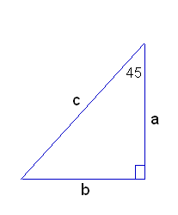
8) If, then the value of to the nearest tenth is…

a) b) c) d)
9) If , then the exact value of is…

a) b) c) d)
10) If, then the exact value of is…
a) b) c) d)

Practice solving problems using special right triangles that involve reading a problem and visualizing or drawing a picture.

- A right triangle has a 60 degree angle, and the leg adjacent to that angle has a length of 7 in. Find the length of the other leg.

- A right triangle has a 45 degree angle, and the hypotenuse has a length of 8 ft. Find the length of a leg.

- The hypotenuse of a right triangle with a 30 degree angle has a length of 9 cm. What is the length of the leg adjacent to the 30 degree angle?

- The diagonal of a square has a length of 18 cm. Find the area of the square.

- The height of an equilateral triangle is 6 in. Find the perimeter of the triangle.

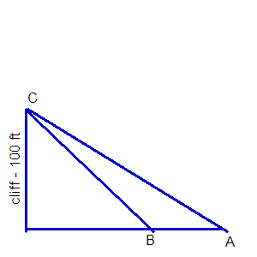
- Albert is standing at point A. He takes a sighting to the top of a cliff, (point C). The angle of elevation is 30 degrees. Becky is standing at point B and takes a sighting to the top of the same cliff, (point C). The angle of elevation is 45 degrees. If the cliff is 100 feet high, find the exact distance between Albert and Becky.

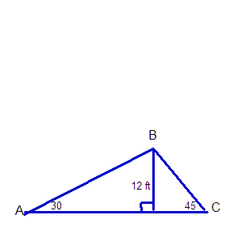

- A roof is short and steep on one side, and longer and more gradual on the other side. (See diagram shown)

- Calculate the number of linear feet of roofing required, (from A to B to C).

- Find the length of the longest building the roof would cover, (from point A to point C).

Still need more practice? Try these additional problems using Special Right Triangles

1. Determine the length of the altitude of an equilateral triangle whose side lengths measure 5 units.

2. If one leg of a right triangle has length 5 and the adjacent angle is 30°, what is the length of the other leg and the hypotenuse?

3. If one leg of a 45°–45°–90° triangle has length 5, what is the length of the hypotenuse?

4. The pitch of a symmetrical roof on a house 40 feet wide is 30º. What is the length of the rafter, r, exactly and approximately. (Adapted from OSPI Geometry Crosswalk)

Application problems with right triangles

G.3.D Know, prove, and apply the Pythagorean Theorem and its converse.
On the EOC questions asked about G.3.D will be multiple choice or completion items and will be in context.

5. A juice box has a base of 6 cm by 8 cm and a height of 12 cm. A straw is inserted into a hole in the center of the top. The straw must stick out 2 cm so you can drink from it. If the straw must be long enough to touch each bottom corner of the box, what is the minimum length the straw must be? (Assume the diameter of the straw is 0 for the mathematical model.) Include a sketch of the juice box labeling the dimensions. (Adapted from OSPI Geometry Crosswalk)

6. A rectangular prism is shown. The base of the prism is a square. The length of the diagonal from top corner A to opposite bottom corner B is 2 feet. Determine the exact length of the box in inches. (Adapted from OSPI Mathematics Assessment Updates for 2011: End-of-Course High School Proficiency Exams)

7.
Determine whether a triangle with the following coordinates is acute, right or obtuse using the Distance Formula and the inverse of the Pythagorean Theorem.
A (-2, 1), B(2, 5) and C(9, -3)

Using sine, cosine and tangent ratios to solve problems

G.3.E Solve problems involving the basic trigonometric ratios of sine, cosine, and tangent.
On the EOC questions asked about G.3.E will be multiple choice or short answer items and will be in context.
Note: You may want to use the EOC formula sheet to access the trig ratios.

8. A 12-foot ladder leans against a wall to form a 60° angle with the ground. How many feet above the ground is the point on the wall at which the ladder is resting? Include a sketch of the situation.

9. A 13-foot ladder is leaning against a brick wall. The top of the ladder touches the wall 12 feet (ft) above the ground. How far is the base of the ladder from the wall? Include a sketch of the situation.

- Billy is standing on the top of a backyard swing set slide. As he looks back, he notices that the angle of depression for the 8 foot ladder foot is 57 degrees. How high off the ground is Billy? Make a sketch of the situation.

- Sally has measured the shadow cast by the blue spruce tree in her family’s front yard to be about 64.25 feet. She estimates that the angle of elevation when she is standing at the end of the shadow to the top of the blue spruce is 50 degrees. Determine (a) the height of the tree and (b) the distance Sally is from the top of the tree. Make a sketch of the situation.

35˚
200 ft
16.

